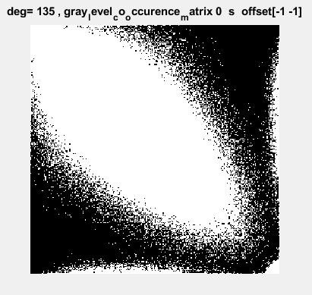

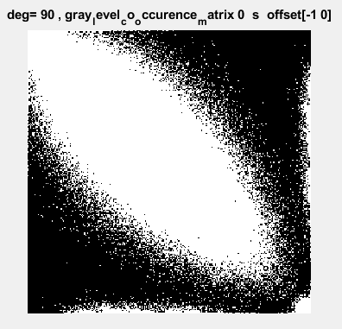

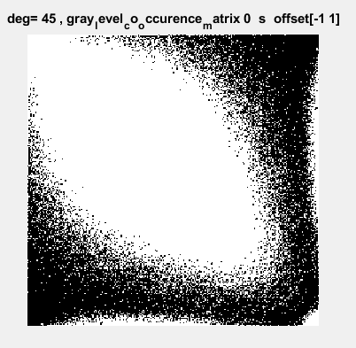

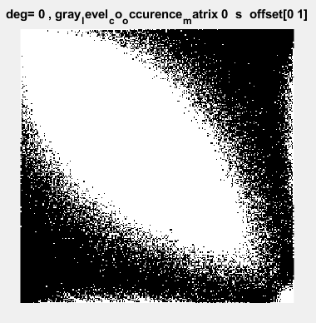

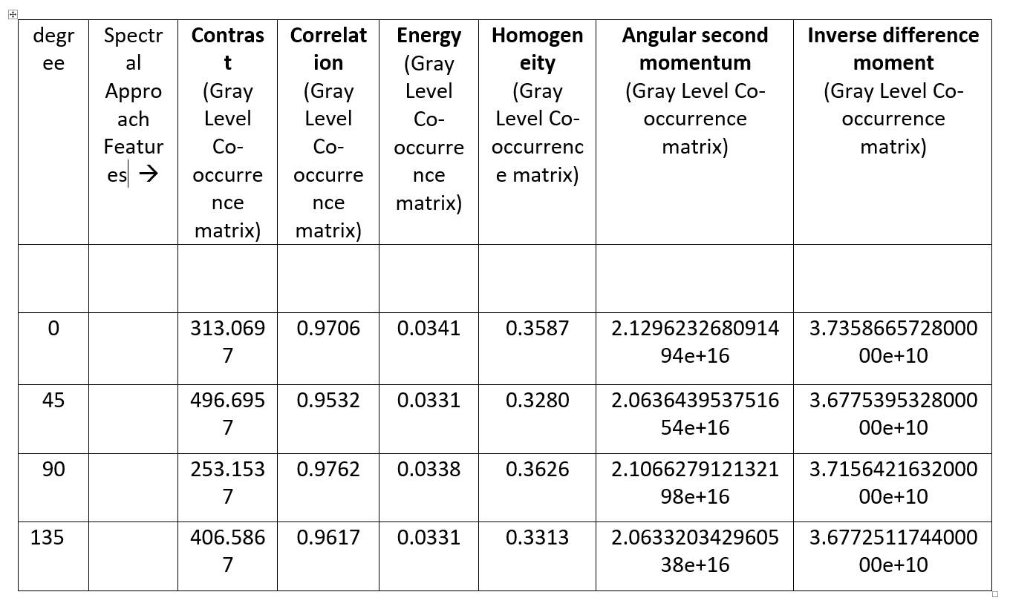

|  |  |  |  |  |  |  |  |
| --- | --- | --- | --- | --- | --- | --- | --- |
| degree | Spectral Approach Features 🡪 | **Contrast**  (Gray Level Co-occurrence matrix) | **Correlation**  (Gray Level Co-occurrence matrix) | **Energy**  (Gray Level Co-occurrence matrix) | **Homogeneity**  (Gray Level Co-occurrence matrix) | **Angular second momentum**  (Gray Level Co-occurrence matrix) | **Inverse difference moment**  (Gray Level Co-occurrence matrix) |
|  |  |  |  |  |  |  |  |
| 0 |  | 313.0697 | 0.9706 | 0.0341 | 0.3587 | 2.129623268091494e+16 | 3.735866572800000e+10 |
| 45 |  | 496.6957 | 0.9532 | 0.0331 | 0.3280 | 2.063643953751654e+16 | 3.677539532800000e+10 |
| 90 |  | 253.1537 | 0.9762 | 0.0338 | 0.3626 | 2.106627912132198e+16 | 3.715642163200000e+10 |
| 135 |  | 406.5867 | 0.9617 | 0.0331 | 0.3313 | 2.063320342960538e+16 | 3.677251174400000e+10 |